**CSF 2113 Lab 3.1 Iterations**

1. **for loop statement in Python using a list of values**
2. What is the output of following code segment?

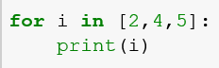

|  |
| --- |
|  |

1. What is the output of following code segment?

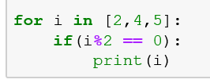

|  |
| --- |
|  |

1. What is the output of following code segment?

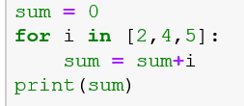

|  |
| --- |
|  |

1. What is the output of following code segment?

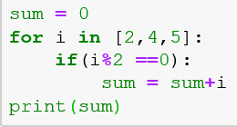

|  |
| --- |
|  |

1. What is the output of following code segment?

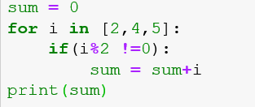

|  |
| --- |
|  |

1. What is the output of following code segment?

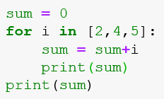

|  |
| --- |
|  |

1. What is the output of following code segment?

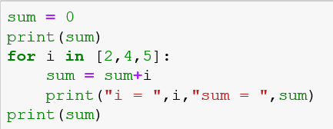

|  |
| --- |
|  |

1. What is the output of following code segment?

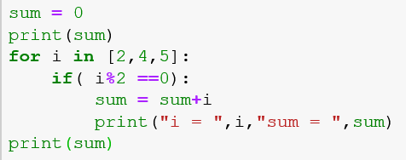

|  |
| --- |
|  |

1. **for loop statement in Python using range**
2. What is the output of following code segment?

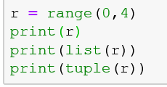

|  |
| --- |
|  |

1. What is the output of following code segment?

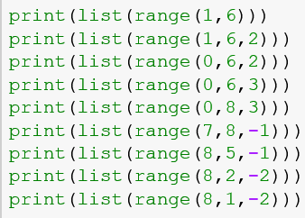

|  |
| --- |
|  |

1. What is the output of following code segment?

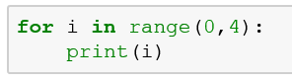

|  |
| --- |
|  |

1. What is the output of following code segment?

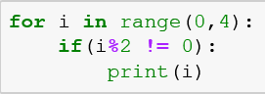

|  |
| --- |
|  |

1. What is the output of following code segment?

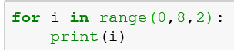

|  |
| --- |
|  |

1. What is the output of following code segment?

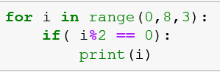

|  |
| --- |
|  |

1. What is the output of following code segment?

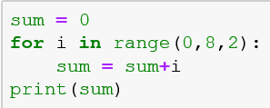

|  |
| --- |
|  |

1. What is the output of following code segment?

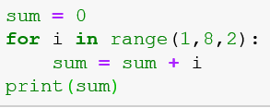

|  |
| --- |
|  |

1. What is the output of following code segment?

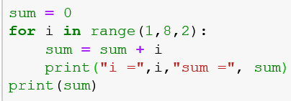

|  |
| --- |
|  |

1. What is the output of following code segment?

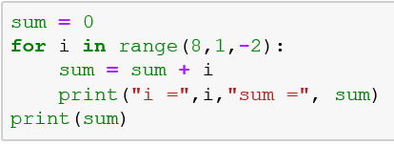

|  |
| --- |
|  |

1. **for loop statement in Python using range**
2. Write a program which take a range from the users and display all numbers in the range.

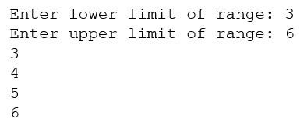

|  |
| --- |
|  |

1. Write a program which take a range from the users and display all odd numbers in the range.

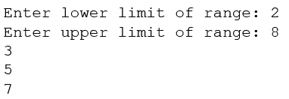

|  |
| --- |
|  |

1. Write a program which take a range from the users and display all numbers which are multiple of 5 in the given range.

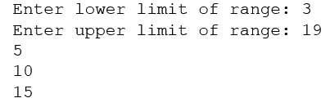

|  |
| --- |
|  |

1. Write a program which take a range from the users and display sum of the numbers in the given range?

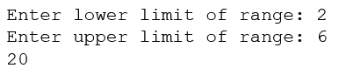

|  |
| --- |
|  |

1. Write a program which take a range from the users and display sum of the all numbers which are multiple of 5 in the given range?

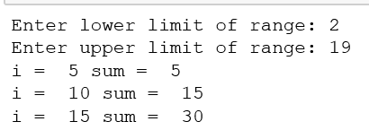

|  |
| --- |
|  |

**End of Lab**